Detailed Software Technical Design (DSTD)
For
C2C couriers

Table of Contents

1 Introduction 5
1.1 Purpose 5
1.2 Scope 5
1.3 Definitions, Acronyms and Abbreviations 5
1.4 References 5
2 Assumptions 6
3 PROJECT OVERVIEW AND USECASE DIAGRAMS 6
4 Detailed Design for Module: <<Module Name>> 7
4.1 Detailed Design for Feature: <<Feature Name>> 7
4.1.1 User Profile 7
4.1.2 Navigation Map 7
4.1.3 UI Screen Design 7
4.1.3.1 Screen Layout 7
4.1.3.2 Validations 8
4.1.4 Object Model/Data Flow Design 8
4.1.4.1 Interface Description 8
4.1.4.2 Class Design 8
4.1.4.2.1 Algorithmic/Business Logic Description (Optional) 8
4.1.4.2.2 Local Data Structure (Optional) 8
4.1.4.3 Data Transfer/Value objects 8
4.1.4.4 Related Database Tables 9
4.1.4.5 Dependencies with Other Sub-systems/Components 9
4.2 Detailed Design for Feature: <<Feature Name>> 9
5 Detailed Design for Module: <<Module Name>> 10
6 Database Design 11
6.1 Entity Relationship Diagrams 11
7 Packaging/Folder Structure and System Artifacts 12
7.1 System Artifacts 12
8 Core Technical Services Design 13
8.1 Persistence 13
8.2 Inter-process Communication 13
8.3 Authentication and Authorization 13
8.4 Error Handling 13
8.5 Logging 13
8.6 Transaction Management 13
8.7 Other Applicable Technical Services 13
9 Non Functional Requirements 14
Appendix 14
1. Design Metrics to be Used 14
2. Supplementary Information 14
3. DQI – Design Quality Index Checklist 14

Document Revisions

Date | Version | Description | Author | Reviewer | Approver

Information Handling

These documents are strictly for Virtusa/Client use only. They shall not be shared with an external party other than the client concerned. These documents should always be kept securely and employees shall use reasonable care protecting these documents from unauthorized use or disclosure to a third party. This category also covers client intellectual property where Virtusa has a non-disclosure agreement with the client.

Introduction

Purpose

The purpose of C2C couriers is to automate the existing manual system by the help of computerized equipments and full-fledged computer software, fulfilling requirements so that their valuable data/information can be stored for a longer period with easy accessing and manipulation of the same. The required hardware and software are easily available and easy to work with. It can assist the user to concentrate on their other activities rather to concentrate on record keeping. Basically the project describes how to manage for good performance and better service for the clients.

Scope
It may be helpful in collecting the information in a very short time ,the collection
Will be obvious , simple and sensible. It will help the customer to know the tracking details of the passed year perfectly and vividly and also helps in reducing the cost of collecting the management and collection procedure.
- It satisfy the user requirements
- Be easy to operate
- Have a good user interface
- Be expandable
- Delivered on schedule within the budget.

Definitions, Acronyms and Abbreviations
- Tenant (or client): A business entity using the services offered by the CSP and accepting some sort of service level agreement.
- Service: A means of delivering value to customers by facilitating outcomes customers want to achieve without the ownership of specific costs and risks.
- Wide Area Network (WAN): A telecommunications network that interconnects locations extended over a large geographical distance.

References

[This sub-section must provide a complete list of all references. Identify each document by title, document number and the version. Specify the sources from which the references can be obtained.

Assumptions

[List the assumptions, if any, here.]

PROJECT OVERVIEW AND USECASE DIAGRAMS
Project Overview:

USE CASE DIAGRAM

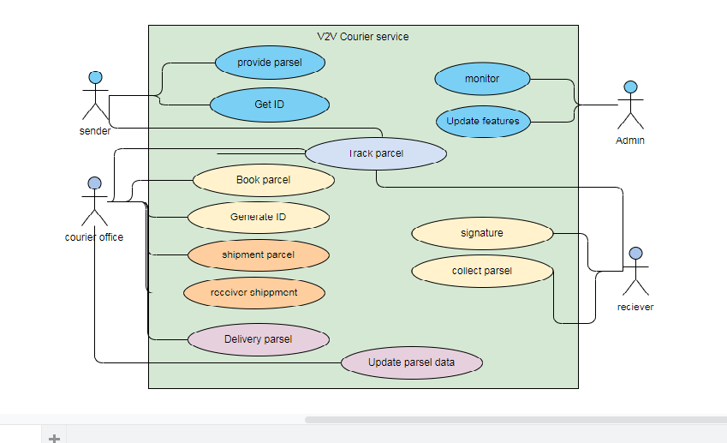

Detailed Design for Module: <<Module Name>>

This section describes the detailed design for the <<Module Name>> module/sub-system. [Save the design images separately as rose, Visio or jpeg images and provide reference or link to them from the word document.]

To include Sequence diagrams for each of the transactions and data flow
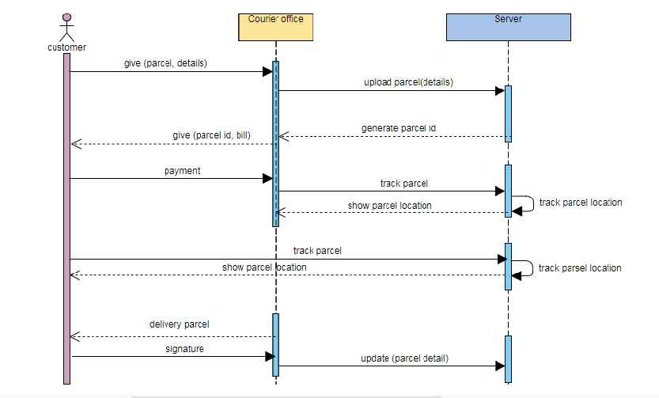

Detailed Design for Feature: <<Feature Name>>

[This section describes the detailed design for the feature including the user interface design.]

User Profile

[Describe the different user types with the security profiles and specify the roles that can access these screens.]

Navigation Map

[Describe the navigation map along with use case traceability of all screens for this feature.]

UI Screen Design

Page Summary
Name | Search for Customer File
Description | The user retrieves the customer information based on the search criteria such as File ID, last name, first name, middle name, business name, SSN/TIN, address, city, state and/or zip.
Use Case Number | UC-002

Screen Layout

[Include a screen shot and describe each element/button in the following table.]

Validations

Error Trigger | Action | Description
If the user group is not selected. | Displays the message “Please select a User Group from the list”. | Prompts the user to select an entry from the User Group list.
User enters an invalid date | Displays the message “Enter a valid date. The date must be in <mm-dd-yyyy> format”. | Displays invalid date message.

Object Model/Data Flow Design

[This sub-section describes the detailed design for the system pertaining to the <<Feature Name>> feature. Interaction diagrams showing the details of the component structure, behavior, or information/control flow may be included in the sub-section devoted to that particular component.]

Interface Description

[Describe the interfaces including component interfaces and interfaces to other systems, products, or networks.]

Class Design
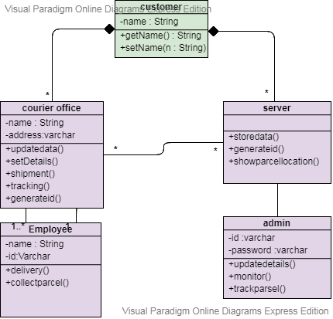

Algorithmic/Business Logic Description (Optional)

[Describe complex algorithms used in the class (if any).]

Local Data Structure (Optional)

[Describe key data structure algorithms used (if any).]

Data Transfer/Value objects

[Based on the design pattern being used, identify and describe the value/transfer objects.]

Related Database Tables

[Give the list of related database tables.]

Dependencies with Other Sub-systems/Components

[Describe the dependencies with other sub-system/components, if any.]

Detailed Design for Feature: <<Feature Name>>

Repeat all sub-sections given in 3.1 for this feature.

Detailed Design for Module: <<Module Name>>

[Detailed design for Module 2.]

Repeat all sub-sections given in section 3 for this module.

Database Design

[This section describes the persistent data and metadata used and generated by the module/sub-system. This will include database schemas (if the database schema is large, use a separate document for database design), registry structures, property file structures, etc.

Models | Tools
Database Entity Relationship Diagrams | ERWin
Object Models | Rational Rose

Entity Relationship Diagrams

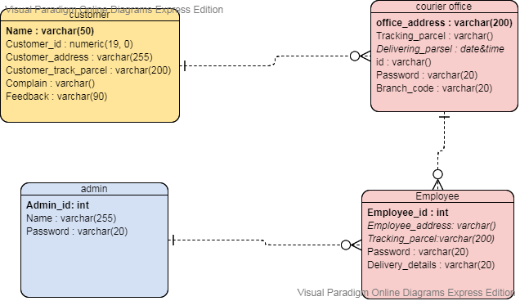

Packaging/Folder Structure and System Artifacts

[This section describes the file structure for the <Project Name> project, which will indicate where the code, unit tests, executables, libraries, etc. are to be placed during implementation. Optionally the file structure can be described in a separate GA chapter and a reference given here.]

[Sample structure

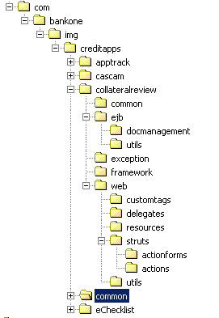
End Sample Structure]

System Artifacts

[Provide information on the Registry structure, INI files, property files, configuration files, etc.]

Core Technical Services Design

[This section describes the detailed design and usage pattern for the core technical services of the system.]

Persistence

[This sub-section captures the detailed design and usage patterns of the persistence service for the application.]

Inter-process Communication

[This sub-section captures the detailed design and usage patterns of the inter-process communication framework for the application.]

Authentication and Authorization

[This sub-section captures the detailed design and usage patterns of the security services for the application.]

Error Handling

This sub-section captures the detailed design and usage patterns of the error handling services for the application.]

Logging

[This sub-section captures the detailed design and usage patterns of the logging framework for the application.]

Transaction Management

[This sub-section captures the detailed design and usage patterns of the Transaction Management service for the application.]

Other Applicable Technical Services

[This sub-section captures the detailed design and usage patterns of the other core technical services to be handled by the system such as the installation mechanism, failure prevention, fault tolerance, caching design, internationalization, validation framework, client and server initialization, error handling, etc.]

9 Non Functional Requirements

Appendix

[Presents information that supplements the design specification.]

Design Metrics to be Used

[A description of all design metrics to be used during the design activity is listed here.]

Supplementary Information

[Provide as required.]

DQI – Design Quality Index Checklist
This checklist shall be used to perform self-review as a reference while preparing software design.


